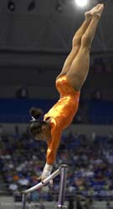


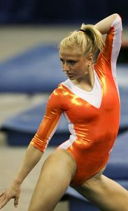
The Art of Motion:
University of Florida Gymnastics
On sale now is the brand new DVD highlighting the 2007
SEC and NCAA Northeast Region Champions.

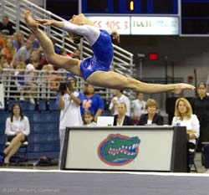
Celebrity guest host Bela Karolyi takes us through shot after shot of impossible performances from some of the best women athletes in the country! Rhonda Faehn, head coach of the Lady Gators, discusses how she helps prepare her team for each meet. You’ll even get exclusive interviews with the gymnasts, behind-the-scenes looks at how the team trains, and what they do when they’re not hitting the mats.

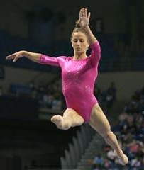
This exclusive DVD will includes a collectable University of Florida Gymnastics refrigerator magnet with next year’s schedule and a one free admission to any home meet of your choice during the 2008-2009 season.

Call 1-800-GATOR-GYM or visit www.gatorgymnasticsDVD.com
to get your copy today!
Only
$19.95!

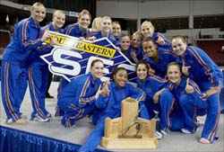


DVD Theme song: “Let’s Get It Started” by the Black-Eyed Peas!

